**Freemans Grattan Holdings**

16

**Virgin Media 50mb Guest WiFi Broadband**

**Setup and troubleshooting**

**Steven Ricks**

Contents

FGHGuestFW – Firewall Setup 3

Switch Vlan 3

AP Addresses 3

Troubleshooting 4

Virgin 5

Equipment 6

Checkpoint UTM-1 Edge X Firewall 6

Cisco Switch VL00A01 6

Virgin Media Router 6

Virgin Fibre Switch. OS6250-8M 6

Diagram 7

# FGHGuestFW – Firewall Setup

Checkpoint UTM-1 Edge X Firewall.

Factory reset – Hold reset button for 7 seconds. Allow to reboot.

Connect laptop to Lan port.

Give Laptop IP address 192.168.10.50 255.255.255.0

Open Web browser and go to ……http://192.168.10.1

Choose password -

Connect WAN port.

Run Wizard

WAN IP address - 80.193.67.14

Gateway - 80.193.67.13

# Switch Vlan

3255

# AP Addresses

Set Ip addresses on APs using meraki.com web Gui.

Reception – 192.168.10.60

1st Floor – 192.168.10.61

2nd Floor – 192.168.10.62

3rd Floor – 192.168.10.63

3rd Floor - 192.168.10.66

4th Floor – 192.168.10.64

5th Floor – 192.168.10.65

Board Room - 192.168.10.67

Air Marshall - 192.168.10.68

Gateway - 192.168.10.1

# Troubleshooting

Check my.meraki.com from a wireless device, i.e. phone.

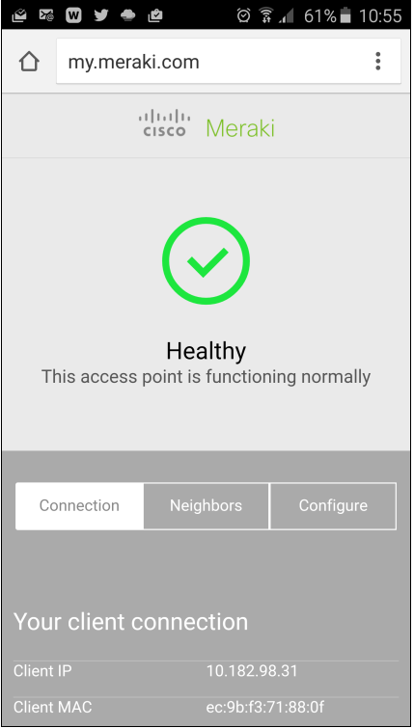

Go to <https://meraki.cisco.com/>, log in and check the status of our setup.

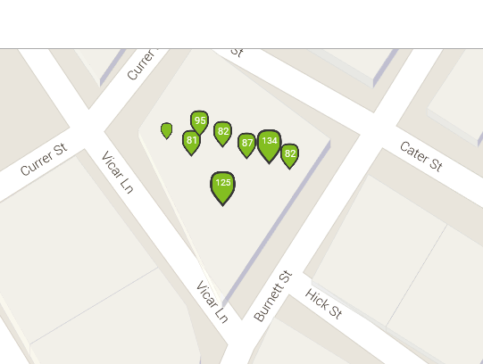

# Virgin

In case of a service issue, please call Virgin Media Faults Management Centre on

0800 052 0800, quote your PIN (3626)

# Equipment

## Checkpoint UTM-1 Edge X Firewall

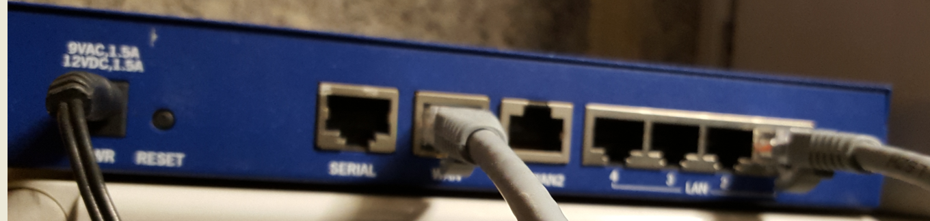

## Cisco Switch VL00A01

Port 44 to Firewall

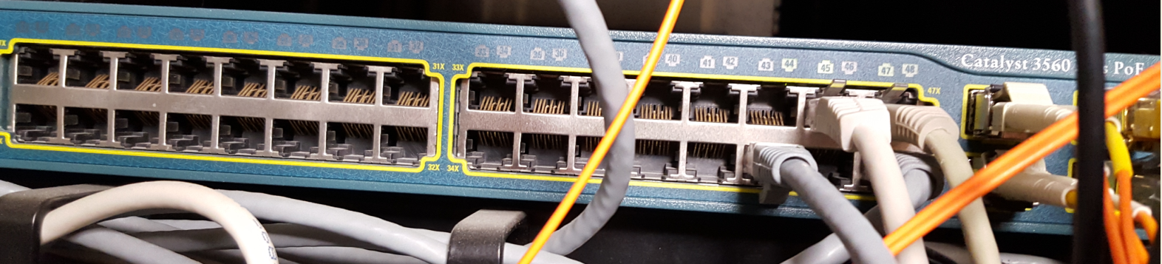

## Virgin Media Router

Port GE0/0 to Firewall

Port GE0/1 to Virgin Media Fibre switch.

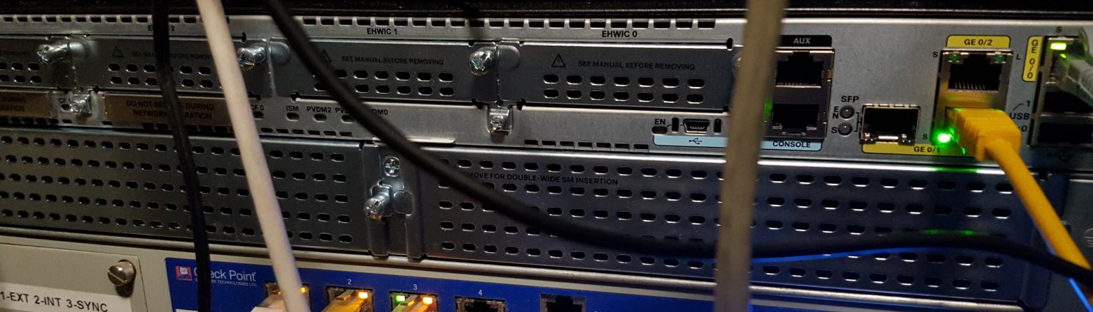

## Virgin Fibre Switch. OS6250-8M

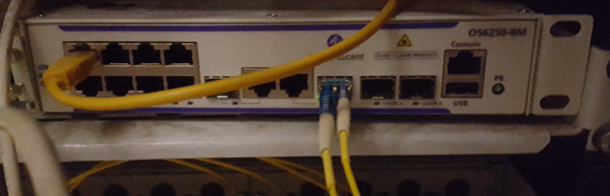

# Diagram

GE0/1

GE0/0

Port 44

Checkpoint Firewall

OS6250-8M Virgin Media Fibre Switch

Virgin Media Router

VVL00A01